Q1)

# Average Output Voltage:

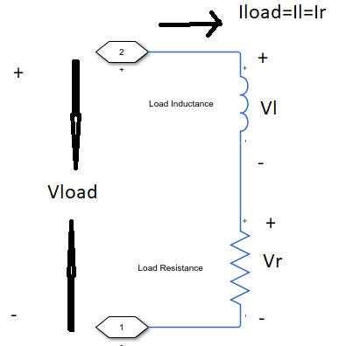

Figure 1 Load Voltage and Current Diagram

As can be seen at Figure X , Load voltage can be found with respect to Load current, inductance and resistance value. However, we can not know load current with respect to time. Only average value of current is given, ripple of load current is not known.So, Average voltage of load should be found by using only resistance value and average current of load.

If required analytical explanation,



Equation 1

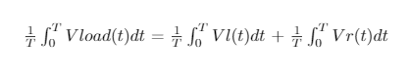

Equation 2

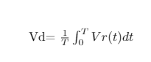

Equation 3

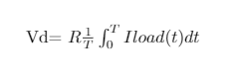

Equation 4

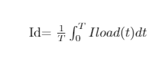

Equation 5

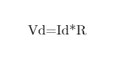

Equation 6

Equation 1 shows that KVL is valid for load. Series RL circuit has common current. For the time independent formulation, we take a mean value of each side of equation like Equation 2. For ındcutor, second voltage law says that mean value of inductor voltage must be zero. So, we can reduce the equation like Equation 3. Then, with property of integral, average value of voltage is written as kind of average current. Finally, Equation 6 is obtained and it indicates that average voltage of output is independent from inductance.

Average output voltage is 160 V for resistor with 4 ohm and this calculation is independent from source side.So, both of circuits, fully and half controlled, have same average voltage.

# Firing Angle Calculation of Fully Controlled Rectifier

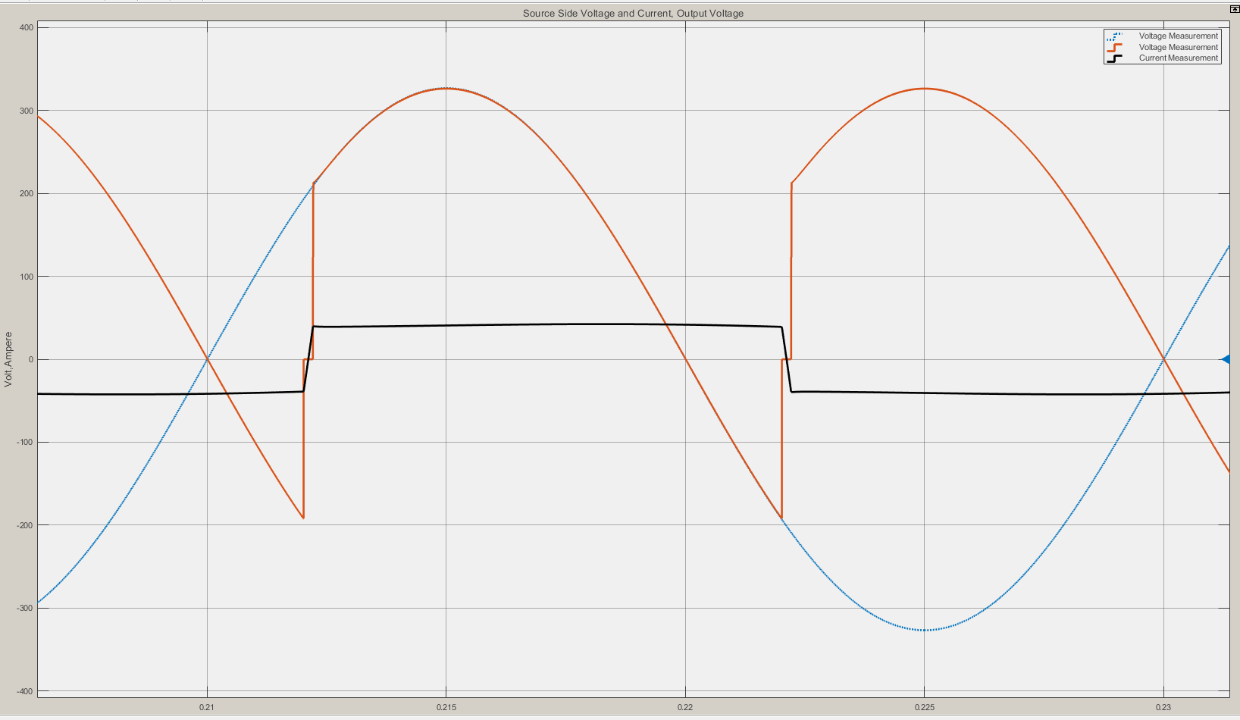

Figure 2

As can be seen Figure 2, there is a commutation at transition between thyristors. It reduces average voltage of rectifier. For the calculation of average voltage, it is not ignored.

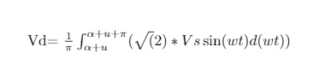

Equation 7

Equation 7 is used for calculate average output voltage of rectifier. The equation contains commutation time.

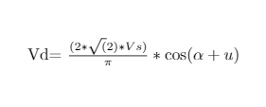

Equation 8

Equation 8 is deducted from equation 7. Average voltage depends on both firing angle and commutation time.

Commutation time depends on line inductance. It balances that current changes with respect to time. It is found by using voltage seconds law(Equation 9).

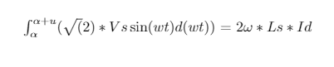

Equation 9

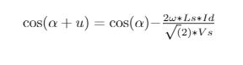

Equation 10

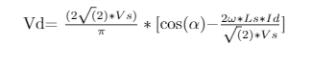

Then, average voltage is written with only firing angle dependency.

If numerical values are placed and firing angle that provides required average current is found 36.1 degree.

# Simulation Results of Fully Controlled Rectifier

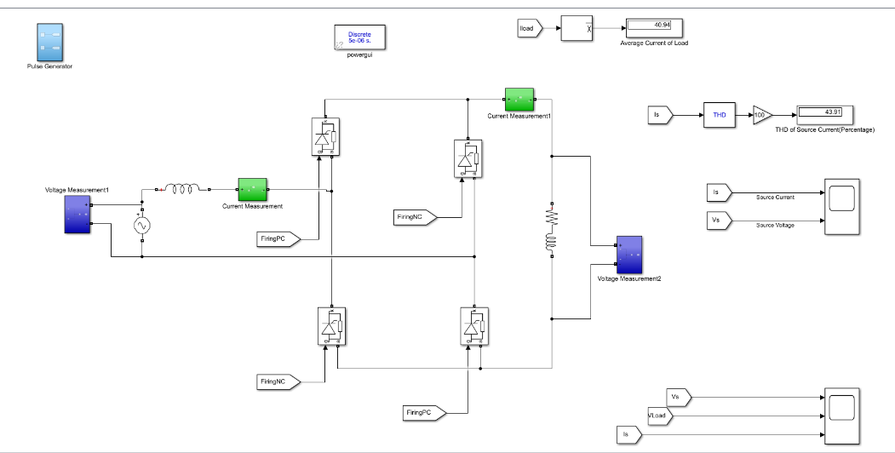

Figure 3

.All circuit diagram shown Figure 3. The circuit has some subsystem that provides firing angles, measurement of currents,voltages and calculation of mean value and THD.

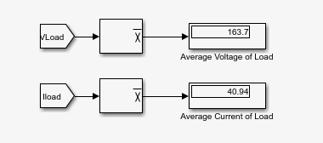

Figure 4

Average voltage and current at figure 4 is almost the same as analytical solution. In simulation, thyrisyors have snubber circuits and it can changes result in small size.

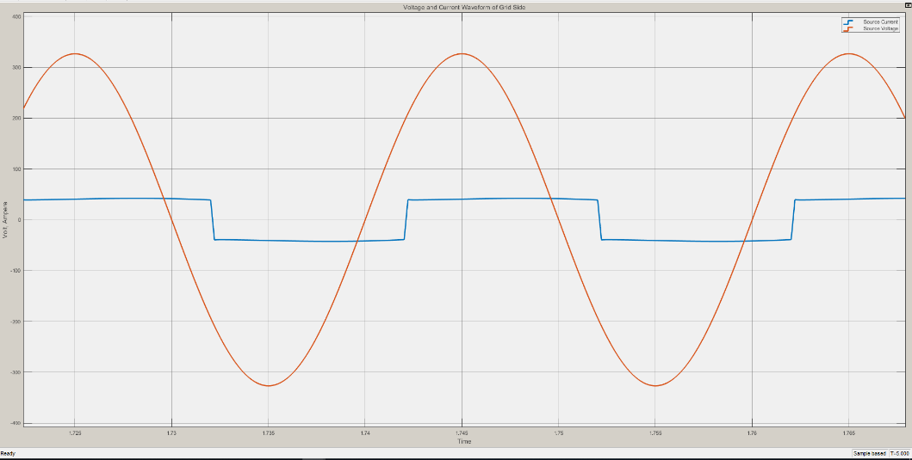

Figure 5

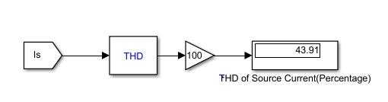

Figure 6

As expected, there is a phase difference at line current and line voltages. The circuit works on rectifier mode because of firing angle is smaller than 90 degree. The phase difference depends on firing angle and commutation time.



THD is smaller than 48% because commutation makes the current more smoother.